TRADE OF PLASTERING

PHASE 2

Module 2
External Work

UNIT: 2

Patent Reveals

Produced by

In cooperation with subject matter expert:
Terry Egan
Some images & text courtesy of Gypsum Industries Ltd.
© SOLAS
Table of Contents
Introduction 1
Unit Objective 1
1.0 Form Patent Reveals Around Door and Window Openings 1
1.1 Select, Measure and Cut Rules to Correct Dimensions 1
1.2 Safety When Using Steel Nails 3

Introduction
Welcome to this section of your course which is designed to introduce you the learner, patent reveals.

Unit Objective
By the end of this unit each apprentice will be able to:
- Form patent reveals around door and window openings

1.0 Form Patent Reveals Around Door and Window Openings

Key Learning Points
- Select, measure and cut rules to correct dimensions
- Safety when using steel nails

1.1 Select, Measure and Cut Rules to Correct Dimensions
The sides of a door or window opening between the frame and the face of the wall, and at right angles to the face of the wall are the reveals. These reveals are referred to as being either flush reveals or patent reveals.
Flush reveals, as their name indicates, finish flush to the face of the wall and are usually finished with the same material and texture of finish as the wall.
Patent reveals, on the other hand when finished, project beyond the floating coat, and are formed by using specially designed rules which, when removed after completion of the reveals provide a projecting narrow band, usually 25mm, around the opening, to facilitate the finishing coat and give a pleasing and accentuating appearance to the opening. These patent reveals are usually used in conjunction with textured external finishes and are generally finished in a plain faced napped finish which contrasts with, and enhances the coarser texture of the completed wall.
The usual mix for this operation is 1 part cement, 1 part lime and 3 parts sand by volume. Sometimes the head of the reveal takes a lot of plaster due to the lintel being too high, to overcome this situation the plasterer can use rapid hardening cement. Refer to the manufacturer’s specification on the amount to be used. This practice saves the plasterer both time and lessens frustration.
Before taking away the patent reveal rules, the plasterer should be completely satisfied that the material has set and hardened sufficiently to avoid damage to the nibs.
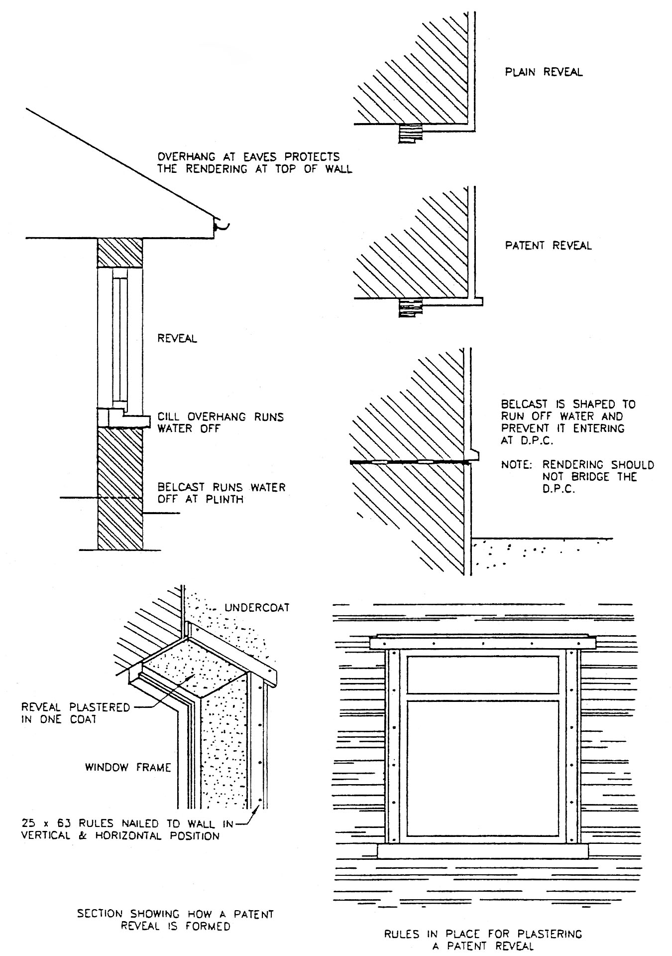
When flush reveals are to be formed with plain faced napped finish work, the reveals are generally laid on first and then the main areas to be finished are worked on.

1.2 Safety When Using Steel Nails

Steel Nails
Key specifications/Special Features:
- Material: hardened steel
- Plating: zinc-plated, yellow zinc-plated and hot-dip galvanized
- Metric sizes: Various sizes

Installed By Hammer
Hardened Steel Nails are similar to the lost head nail but are made from specially hardened zinc-plated steel for making hammered fixing directly into brickwork and concrete without plugging. There are available in lengths up to 100 mm. Goggles must always be worn when driving these nails.

Using Nails
Nails are driven with an appropriate hammer. Use a pin hammer for fine work and a claw hammer for heavier work. Always keep the hammer face clean, by rubbing it with a fine abrasive paper. A dirty hammer face tends to slip on the nail head, damaging the work piece and bending the nail. Keep an eye on the nail and check the angle as it enters the wood. To avoid damage and bending, the hammer shaft at the moment of impact should be at right angles to the nail.

Methods of Using Nails
Always nail the thin piece to the thick piece
Use a length of nail that is about 2½ or 3 times the thickness of the wood it is being driven through. This gives approximately two thirds of the nail to provide the holding power.
When joining two thin pieces, use a nail length 4 to 6mm longer than the combined thickness of the pieces. This allows the protruding end to be clenched over for strength.
Where extra strength is required always dovetail or skew nail. Using this method prevents the nails from being pulled out or working loose.
Where oval or rectangular section nails are used, the widest dimension must be parallel to the grain of the timber. Their use in the opposite direction, across the grain, will normally result in the timber splitting.
When nailing near the end of a piece of timber, the timber has a tendency to split. In order to overcome this, the point of the nail should be tapped with a hammer to blunt the point before the nail is used. The point of a nail tends to part the fibres of the timber and therefore split it, while the blunted end tends to tear its way through the fibres, making a hole for itself.
Pilot holes may be required or specified to receive wire nails in structural joints. These pilot holes should be up to 80% of the nail shank diameter, in order to prevent splitting.
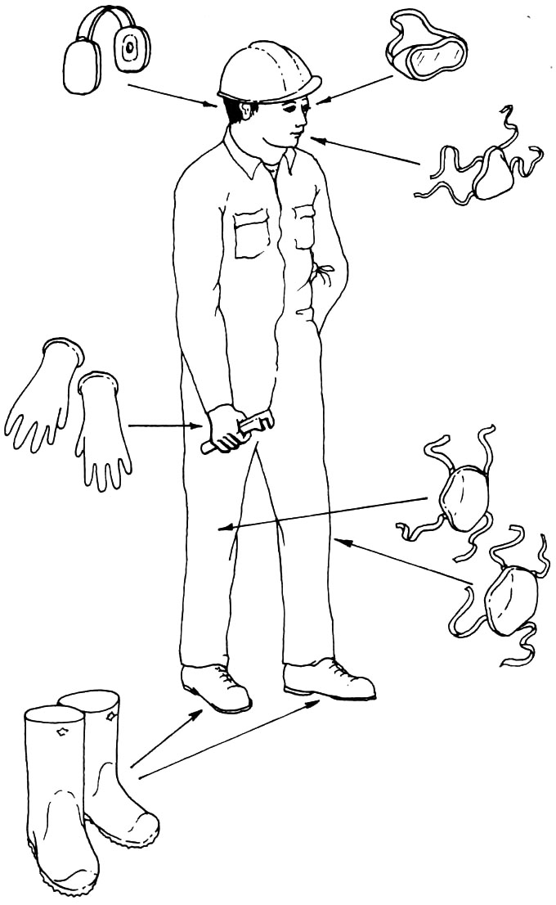
Pilot holes are essential when nailing hardwoods.
Stagger nails across the grain: do not nail in the same grain line more than once, as this will split the wood. Nails in surfaces to be painted should be punched just below the surface ready for filling.
Safety glasses, goggles or eye shields must be worn where there is any foreseeable risk of eye injury. Eye injury can result from:
- Hammering steel nails
- Using power tools – drilling and grinding.
- Hammering and driving tools - cutting, chipping and chiselling.
- Flying particles - dust and chemical splashes.
Protective Clothing

27-33 Upper Baggot Street
Dublin 4

